

**Module - React - Components, State, Props**



1. **What is React JS?**

* React JS is an open-source JavaScript library.
* React is User Interface (UI) library.
* With the use of React we can create one page website.

1. **What is NPM in React JS?**

* The full form of NPM is Node Package Manager.
* NPM is the largest software library.
* NPM is a command-line utility that comes bundled with Node.js, and it allows developers to install, update, and remove packages easily.

1. **What is role of Node JS in React JS?**

* Node.js is commonly used to implement server-side rendering for React.js applications.
* Node.js is used in the development environment for React.js applications
* Node.js providing a runtime environment for server-side rendering, development tools, build processes, API integration, and deployment of React applications.
* Creating JSON (JavaScript Object Notation) APIs for web development is competent due to the high code reusability and access to immediate code sharing in React.js. And Node.js can effectively allow this.
* The combination of Node.js and React can balance the high server requests and load when developers work on web app development.

1. **What is CLI command in React JS?**

* CLI command is use to create passable version of react application using the command line.
* CLI stands for Command line interface.
* React have its own CLI but currently they are only supporting creating an app
* In React.js CLI commands are used to perform various tasks related to project setup, development testing and deployment.

1. **What is components in React JS?**

* Components are independent and reusable bits of code.
* They serve the same purpose as JavaScript functions, but work in isolation and return HTML.
* There are two types of components.
  + - **Class Component:**
* Class components are defined as ES6 classes that extend the React.Component base class.
* When creating a React component, the component's name must start with an upper case letter.

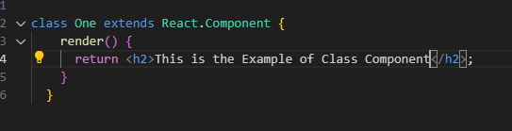

* + - **Function Component**
* Function component is same as JavaScript function.
* Function components can be written using much less code, are easier to understand, and will be preferred in this tutorial.
* Function Component use props as parameter.

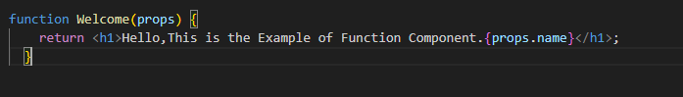

1. **What is Header and Content Components in React Js?**

* In React.js, Header and Content components are typically used to structure the layout of a web application.
* **Header Component**:
* A header is a section at the top of a page that displays site name and navigation.
* The Header component is reusable across different pages or sections of your application, allowing you to maintain a consistent look and feel throughout.

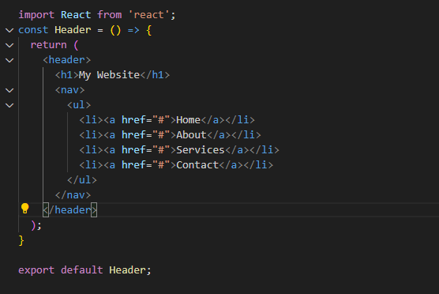

* **Content Component**:
* The Content component holds the main content of the web page.
* It can dynamically render different sections or components based on the user's interactions or the current state of the application.
* Content components often change based on routing or user actions, and they communicate with other components to update the UI accordingly.

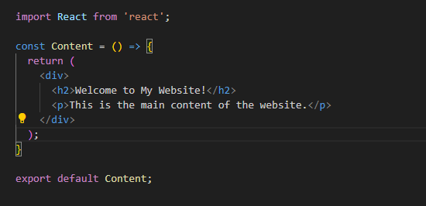

1. **How to install React Js on Windows, linux Operating System? How to install NPM and How to check version of NPM?**

**Installing React.js and npm on Windows:**

- Install Node.js: React.js requires Node.js, which includes npm. You can download the Windows installer from the official Node.js website: https://nodejs.org/

- Visit the website and download the LTS (Long Term Support) version for Windows.

- Run the installer and follow the installation instructions.

Verify Installation:

- After the installation is complete, open a Command Prompt or PowerShell window and enter the following commands to verify that Node.js and npm have been installed successfully:

- node -v

- npm -v

**Installing React.js and npm on Linux:**

**Install Node.js :**

- Open a terminal and use the following commands to install Node.js and npm using a package manager appropriate for your Linux distribution. Here, we'll use apt for Ubuntu/Debian-based systems and dnf for Fedora:

**How to install React JS in Ubuntu and Linux :**

* Install Node.js: sudo apt install nodejs.
* Verify Node.js installation: node -v.
* Install npm: sudo apt install npm.
* Install create-react-app globally: sudo npm install -g create-react-app.
* Create a new React app: create-react-app your_app_name.
* Navigate into the created app directory: cd your_app_name.
* Start the development server: npm start.
* To check the version of NPM : npm -v